BOOK PRESENTATION
CONSPIRACY TO COMMIT
MASS MURDER
Dublin and Monaghan Car Bombs, 17 May 1974
JOHN O’BRIEN
The deadliest day of the Troubles. More than half a century of unanswered questions.
A former senior detective follows the evidence, challenges accepted explanations and asks why the full truth remains out of reach.
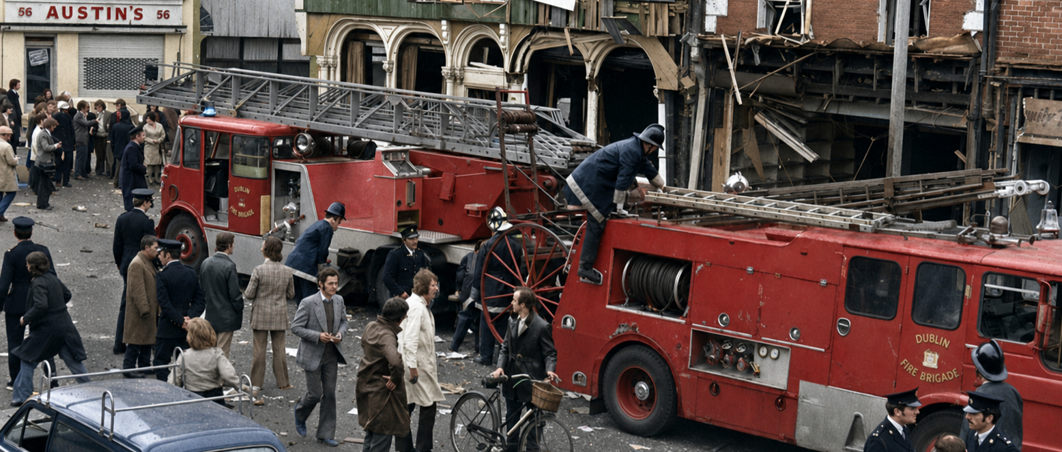
PARNELL STREET – ENTIRE O’BRIEN FAMILY AND SIX OTHER INNOCENTS KILLED – THIRTY FOUR HUMAN BEINGS WERE KILLED THAT DAY
A compelling work of investigative history that reconstructs the political crisis, operational planning and institutional aftermath of the Thirty Four Dublin and Monaghan mass murders. It asks who had the capability to carry out the attacks, what the security and intelligence system knew, and why the full truth has remained hidden for more than fifty years.

IRISH HISTORY • POLITICS • CRIME • STATE ACCOUNTABILITY
COMPLETE  335-page account | FORENSIC  Evidence-led investigation | HUMAN  Victims and eyewitnesses | ILLUSTRATED  Photos, records & diagrams

THE STORY
What Happened - and Why It Still Matters
On Friday, 17 May 1974, three car bombs exploded in central Dublin within minutes of one another. A fourth exploded in Monaghan ninety minutes later. Thirty-four people, including an unborn child, were killed and almost 300 were injured. It was the greatest loss of life on a single day of the Troubles. No one has ever been prosecuted.
Conspiracy to Commit Mass Murder begins with the victims and the lived reality of the attacks, drawing on eyewitness testimony from Garda officers, survivors and those who encountered the immediate aftermath. It then widens the lens to the collapse of Sunningdale, the Ulster Workers’ Council strike, loyalist mobilisation, the UVF’s operational record, British and Irish security capacity, and the network of military, police and intelligence bodies operating in Northern Ireland.
This is not a book built on accusation. It follows the habits of a criminal investigation - motive, opportunity, means, capability, relationships, intelligence and conduct after the crime. Its central argument is both factual and moral: governments may manage political risk, but the murder of civilians creates an enduring duty to pursue the fullest truth that can still be found.
“This is not an assertion in search of supporting facts. It is an examination of the facts, the contradictions and the absences that have accumulated over five decades.”
FROM THE PROLOGUE
The questions at the heart of the book
- Could the UVF, acting alone, have organised and executed the highly coordinated Dublin operation?
- What did the British Army, RUC Special Branch, MI5, MI6, the UDR and their informant networks know before and after the attacks?
- Why did intelligence identifying suspects fail to produce transparent investigation, disclosure or prosecution?
- Did British secrecy and Irish governmental caution combine to prevent full accountability?
How the story unfolds
1 | The political crisis  Sunningdale, the UWC strike, the “Doomsday” narrative and a weakened British government create the tense political background to the attacks.

2 | The operation  Victims, vehicles, timing, explosives, reconnaissance, manpower, deployment and escape are examined as parts of a single criminal plan.

3 | The intelligence eco system  The book maps the Army, police, security services and UDR structures surrounding loyalist organisations in 1973-75.

4 | The long aftermath  From the first investigation to the Hidden Hand Documentary, Barron, Ardagh, MacEntee, HET, Operation Denton, ICRIR and modern secrecy rules, the story is followed through to 2026.
WHY THIS BOOK MATTERS
A Fresh Investigation of an Unresolved Crime
A detective follows the evidence  John O’Brien separates intelligence from courtroom evidence, inference from proof, and institutional failure from individual criminal responsibility. | The victims remain central  The intelligence debate never eclipses the human cost. The O’Brien family, other victims, eyewitness Garda accounts and survivor testimony give the book its emotional centre.

The bombs examined closely  Experienced British and Irish military explosives specialists assess the devices alongside the UVF’s known record, allowing readers to test the accepted claim of capability. | The hidden network made visible  The book brings together Army Intelligence, RUC Special Branch, the UDR, MI5, MI6, psychological operations and loyalist networks in one connected picture.

A powerful organising idea: “Operation Deny”
The book uses Operation Deny as an analytical description - not the name of a formally declared operation - for a recurring British Paradigm: establish an early official account; protect sensitive institutions; narrow the evidence; resist disclosure; prolong proceedings; and concede only what has escaped, because of later inquiry, litigation or public pressure makes unavoidable. The pattern is examined through Ballymurphy, McGurk’s Bar, Bloody Sunday, Dublin and Monaghan, the Miami Showband massacre and the Reavey murders.
What the investigation draws upon
- Official records, parliamentary proceedings, inquiry reports, court judgments and contemporary intelligence material.
- Professional assessments from experienced British and Irish military explosives specialists.
- Garda eyewitness testimony, survivor and family accounts, and the work of campaigners and investigative journalists.
- Detailed examination of UVF organisation, personnel, operational history and links with serving or former security-force members.
- A chronology extending from the political and security crisis of 1971-74 to the legacy and disclosure battles of 2025-26.

“A lifetime of meticulous, disciplined policing experience at the highest level makes his perspective invaluable.”
STEPHEN TRAVERS, AUTHOR AND SURVIVOR OF THE MIAMI SHOWBAND MASSACRE

A clear and accessible voice
The book is written for the general reader. It is morally engaged but careful with evidence, direct in its language and clear about the difference between proven fact, credible inference and unresolved allegation.
THE WIDER APPEAL
Who Will Find This Book Compelling
Readers drawn to the human story
Readers of Irish history  Anyone interested in the Troubles, modern Ireland, policing, politics and unresolved legacy cases. | Readers of British political history  Those interested in government, intelligence, counter-insurgency, covert operations and state accountability.
True-crime readers  A real unsolved mass-casualty case reconstructed through evidence, witnesses, technical analysis and institutional secrecy. | Families, students and researchers  An accessible account for the public, libraries, universities, historical societies and the Irish diaspora.
Why the book stands out
This is more than a history of a single atrocity. It connects the mechanics of the crime to the political crisis surrounding it, the intelligence system operating around loyalist organisations, and the long struggle by families and campaigners to secure disclosure and accountability.
A Road Explored in the Past – Some Contributers
Dublin and Monaghan Bombings  Joe Tiernan  Superb Ethnographic Research - Unique | Lethal Allies  Anne Cadwallader  Security-force/loyalist overlap and the Glenanne network. Making the Connections. | The Bass Player  Stephen Travers  Miami Showband Massacre Survivor and Lifelong Advocate for Justice | The Great Deception  John O’Brien  Setting the Legacy Agenda for Operation Deny
A story with continuing relevance
- Written by a former senior detective with direct experience of criminal investigation, state security and international police cooperation.
- Introduced by Stephen Travers, survivor of the Miami Showband massacre, and concluded by Colin Wallace, a former British Army information officer.
- Combines personal testimony, forensic reconstruction, political history and the continuing controversy over intelligence and state secrecy.
- Connects naturally with public commemorations, history events, book festivals, universities, podcasts, radio, television and Irish diaspora audiences.
- Offers strong documentary and audio potential through its central mystery, archival material, eyewitness voices and multi-decade investigative journey.

Why this story remains urgent
The book reaches beyond the fiftieth anniversary into the present. The Dublin and Monaghan murders are not simply a closed historical controversy: modern legacy bodies, national-security restrictions and disclosure rules still shape what the families and the public may ever be permitted to know.

ABOUT THE BOOK
The Author, Key Voices and the Complete Work
John O’Brien
John O’Brien is a retired Detective Chief Superintendent of An Garda Síochána with more than thirty-eight years of service. His senior appointments included divisional command and national responsibility for Interpol and Europol liaison, state security, diplomatic protection, international police cooperation and witness protection. After retirement, he served as a Special Adviser to the Garda Síochána Ombudsman Commission.
He holds an MSc with Distinction in Public Order Studies from the University of Leicester and is the author of A Question of Honour: Politics and Policing and Securing the Irish State. His professional background gives him both the authority to interrogate investigative failure and the discipline to distinguish evidence, intelligence, allegation and inference.
Foreword - Stephen Travers  Author and survivor of the Miami Showband massacre. Travers highlights O’Brien’s courage, compassion and disciplined policing perspective. | Afterword - Colin Wallace  Former British Army information officer and UDR officer. Wallace argues that the full story of Dublin and Monaghan has yet to emerge.
Book details
TITLE | Conspiracy to Commit Mass Murder: Dublin and Monaghan Car Bombs, 17 May 1974
SCALE | Approximately 118,000 words; 335 pages
STRUCTURE | Foreword, prologue, 57 chapters, epilogue, afterword and eight appendices and Indexes
FEATURES | Photographs, documentary exhibits, diagrams, tables, source notes and eyewitness testimony
A complete, illustrated investigation
- A full account of the attacks, their political background and the original investigation.
- A forensic examination of bombing capability, intelligence knowledge and institutional response.
- Eyewitness testimony, survivor perspectives and the voices of those who continued the search for truth.
- Photographs, documentary material, diagrams, tables, source notes and detailed appendices.
THE CENTRAL PROMISE
This is not another general history of the Troubles. It is a concentrated investigation of the deadliest day of the conflict: a human tragedy, an unresolved criminal conspiracy and a continuing test of what democratic states do when the truth threatens powerful institutions.
AUTHOR CONTACT

John O’Brien | Email: ______________________________ Telephone: ___0872644664

